Q1: A country's labor force is the sum of the number of employed and unemployed workers. The accompanying table provides data on the size of the labor force and the number of unemployed workers for different regions of the United States.

|  |  |  |  |  |
| --- | --- | --- | --- | --- |
| Labor force (thousands) | | | Unemployment (thousands) | |
| Region | April 2013 | April 2014 | April 2013 | April 2014 |
| Northeast | 28,407.2 | 28,288.9 | 2,174.4 | 1,781.3 |
| South | 56,787.8 | 57,016.4 | 4,089.9 | 3,363.8 |
| Midwest | 34,320.0 | 34,467.0 | 2,473.7 | 2,109.0 |
| West | 36,122.2 | 36,307.3 | 2,940.8 | 2,535.7 |

a) Calculate the number of workers employed in each of the regions in April 2013 and April 2014. Use your answers to calculate the change in the total number of workers employed between April 2013 and April 2014.

|  |  |  |  |  |  |  |  |
| --- | --- | --- | --- | --- | --- | --- | --- |
| Region | April 2013 | | | April 2014 | | |  |
|  | Labor Force – unemployed | | ***Employed*** | ***Employed*** | | | ***Change*** |
| North-east | 28,407.2 – | 2,174.4 | ***=26,232.80*** | 28,288.9 | 1,781.3 | ***26,507.60*** | 274.80 |
| South | 56,787.8 – | 4,089.9 | ***=52,697.90*** | 57,016.4 | 3,363.8 | ***53,652.60*** | 954.70 |
| Mid-west | 34,320.0 – | 2,473.7 | ***=31,846.30*** | 34,467.0 | 2,109.0 | ***32,358.00*** | 511.70 |
| West | 36,122.2 – | 2,940.8 | ***=33,181.40*** | 36,307.3 | 2,535.7 | ***33,771.60*** | 590.20 |
|  | | | | | | | ***Total 2,331.40*** |

b) For each region, calculate the growth in the labor force from April 2013 to April 2014.

**Labor Force Growth Rate = $\frac{LFApril 2014 – LF April 2013}{LF April 2013}X 100$**

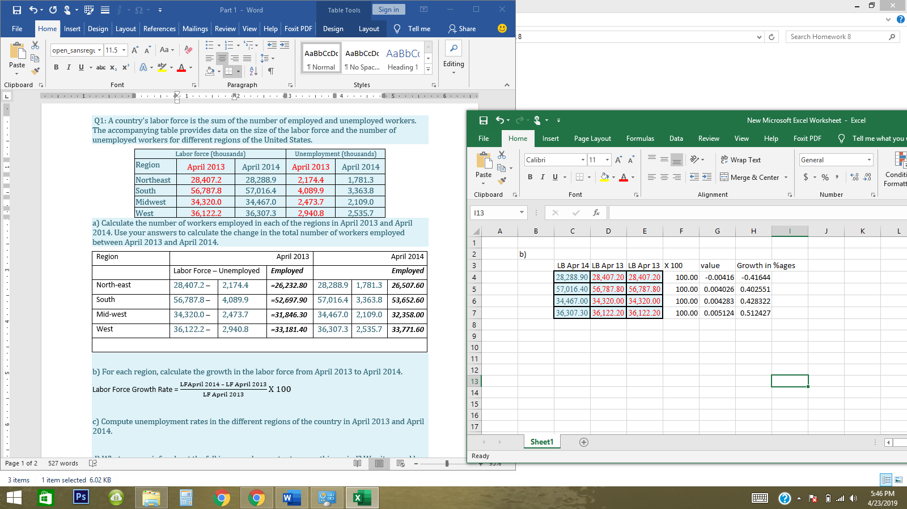

c) Compute unemployment rates in the different regions of the country in April 2013 and April 2014. 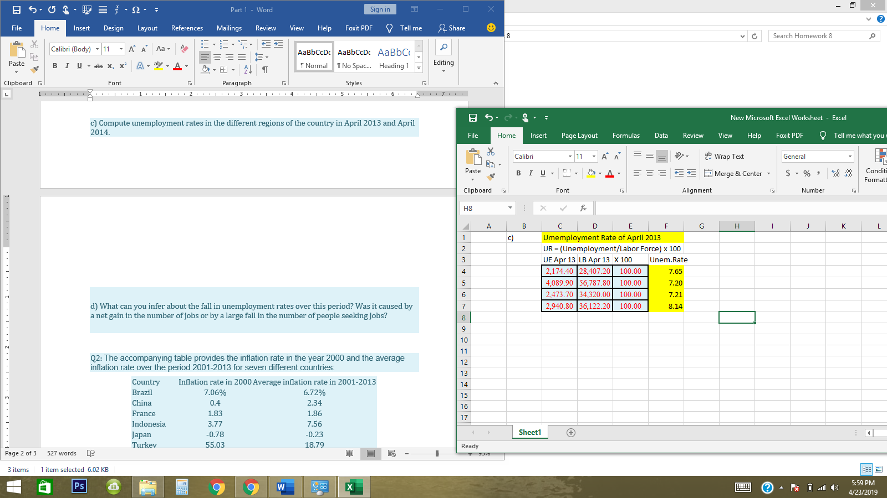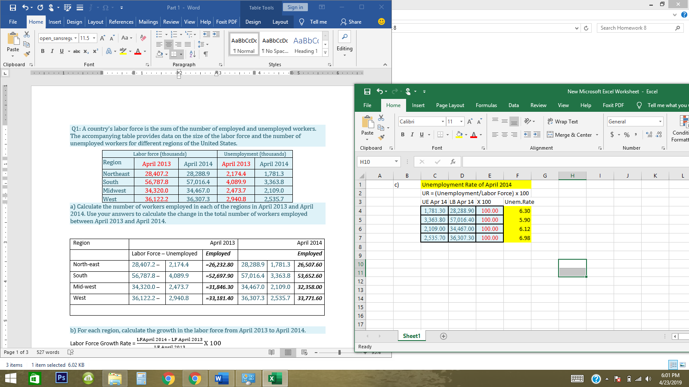

d) What can you infer about the fall in unemployment rates over this period? Was it caused by a net gain in the number of jobs or by a large fall in the number of people seeking jobs?

d): With reference to a) we can see there is a very minor increase in employment numbers in a time of one year *i.e. from 26,232.80 in April 2013 to 26,507.60 in April 2014 in North-east region* and similarly in other specified regions - which infers that there could be a fall in number of people seeking jobs – possibly could have moved to other regions, cities or foreign countries in quest of jobs opportunities or negligible amount of people could have gain new jobs.

-----------------------------x-----------------------------------------x-------------------------------------------x---------------------

Q2: The accompanying table provides the inflation rate in the year 2000 and the average inflation rate over the period 2001-2013 for seven different countries:

|  |  |  |
| --- | --- | --- |
| Country | Inflation rate in 2000 | Average inflation rate in 2001-2013 |
| Brazil | 7.06% | 6.72% |
| China | 0.4 | 2.34 |
| France | 1.83 | 1.86 |
| Indonesia | 3.77 | 7.56 |
| Japan | -0.78 | -0.23 |
| Turkey | 55.03 | 18.79 |
| United States | 3.37 | 2.43 |

a) Given the expected relationship between average inflation and menu costs, rank the countries in descending order of menu costs using the average inflation over the period 2001-2013.

a) The countries with the highest average inflation rates should have the highest menu costs. Order: Turkey, Indonesia, Brazil, United States, China, France, Japan.

|  |  |  |
| --- | --- | --- |
| S.no | Ranking (Descending Order – from High to Low) | Average Inflation Rate 2001-13 |
| 1st | Turkey | 18.79% |
| 2nd | Indonesia | 7.56% |
| 3rd | Brazil | 6.72% |
| 4th | United States & China | 2.34 |
| 5th | France | 1.86 |
| 6th | Japan | -0.23 |

b) Rank the countries in order of inflation rates that most favored borrowers with ten-year loans that were taken out in 2000. Assume that the loans were agreed upon with the expectation that the inflation rate for 2001 to 2013 would be the same as the inflation rate in 2000.

b) The countries with an average inflation rate higher than the inflation rate in 2000 should favor borrowers with ten-year loans payable in 2013 (for example China and Indonesia in the above countries list). The higher the difference between the average inflation rate during 2001–2013 and the inflation rate in 2000, the lower the real value of the loan. Order: Indonesia, China, Japan, France, Brazil, United States, Turkey.

|  |  |  |
| --- | --- | --- |
| S.no | Ranking (Inflation Rates – From Most favored borrowers to Least Favored borrowers – for long term loan) | Difference between Avg: Inflation Rate 2001-2013 and 2000. |
| 1st | Indonesia | 3.79 |
| 2nd | China | 1.94 |
| 3rd | Japan | 0.55 |
| 4th | France | 0.03 |
| 5th | Brazil | -0.34 |
| 6th | US | -0.94 |
| 7th | Turkey | -36.24 |

c) Did borrowers who took out ten-years loans in Japan gain or lose overall versus lenders? Explain.

c) During this period, borrowers would have gained at the expense of lenders in Japan since − 0.23% is greater than −0.78%. Average inflation in Japan was greater between 2000 and 2013 than it was in 2000.

-----------------------------x-----------------------------------------x-------------------------------------------x---------------------

Q3: Read the [Report of the commission on the measurement of economic performance and social progress](https://moodle.unive.it/mod/resource/view.php?id=101151), available in the section Reading Material.

Please, discuss what are the classical issues associated to the GDP.

Ans: Following are the problems with GDP:

The income distribution is not accounted in GDP calculation and is neglected.

Public healthcare services, Tuition assistance and childcare or other services which comes under the category of Non- monetary services are also not considered.

It does not consider negative externalities such as air pollution, smoking, drinking alcohol, noise pollution, passive smoking etc.

It accounts "defensive spending" = spending for things you don't really want but you need, for example defense and insurance etc.

-----------------------------x-----------------------------------------x-------------------------------------------x---------------------

Q4: Boris Borrower and Lynn Lender agree that Lynn will lend Boris $10,000 and that Boris will repay the $10,000 with interest in one year. They agree to a nominal interest rate of 8%, reflecting a real interest rate of 3% on the loan and a commonly shared expected inflation rate of 5% over the next year.

a)      If the inflation rate is actually 4% over the next year, how does that lower-than-expected inflation rate affect Boris and Lynn? Who is better off?

a) If the actual inflation rate (price increase rate) is 4%, Lynn is better off and Boris is worse off. Boris had expected to pay, and Lynn had expected to receive, a real interest rate of 3%. However, with an actual inflation rate of 4%, an 8% nominal interest rate yields areal interest rate of 4% (8% −4% =4%). So, in real terms, Boris pays more, and Lynn receives more, than was expected.

b)      If the actual inflation rate is 7% over the next year, how does that affect Boris and Lynn? Who is better off?

b) If the actual inflation rate is 7%, Boris is better off and Lynn is worse off. Boris had expected to pay, and Lynn had expected to receive, a real interest rate of 3%. However, with an actual inflation rate of 7%, an 8% nominal interest rate yields areal interest rate of 1% (8% −7% =1%). So, in real terms, Boris pays less, and Lynn receives less, than was expected.

-----------------------------x-----------------------------------------x-------------------------------------------x---------------------